[Solar Energy Materials and Solar Cells 174 (2018) 445–452](http://dx.doi.org/10.1016/j.solmat.2017.09.025)



Contents lists available at [ScienceDirect](http://www.sciencedirect.com/science/journal/09270248)

Solar Energy Materials and Solar Cells

journal homepage: [www.elsevier.com/locate/solmat](https://www.elsevier.com/locate/solmat)

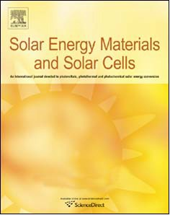

# Design, fabrication and optical characterizations of large-area lithography- free ultrathin multilayer selective solar coatings with excellent thermal

stability in air

Hao Wang, Hassan Alshehri, Hang Su, Liping Wang⁎

*School for Engineering of Matter, Transport & Energy, Arizona State University, Tempe, AZ 85287, USA*

## A R T I C L E I N F O

*Keywords:*

Solar thermal Selective absorber Thermal stability Spectroscopy

## A B S T R A C T

A sub-micron-thick selective multilayer solar thermal absorber made of tungsten, SiO2 and Si3N4 multilayer thin ﬁlms was theoretically designed and experimentally demonstrated in this work. The optical performance was optimized by the particle swarm optimization algorithm for this multilayer absorber, whose spectral selectivity is associated with the Fabry-Perot resonance and anti-reﬂection eﬀects. The designed multilayer absorber was deposited by sputtering and chemical vapor deposition techniques on the wafer scale. Its spectral absorptance characterized by a Fourier Transform Infrared spectrometer (FTIR) was demonstrated to be greater than 0.95 in the solar spectrum and less than 0.1 emittance in the mid-infrared with angular insensitivity. Temperature dependent FTIR measurements with an optical ﬁber setup revealed stable optical performance up to 600 °C in ambient, while thermal cycle testing showed its long-term thermal stability at 400 °C. Theoretical analysis of solar to power eﬃciency for a Carnot heat engine driven by the Solar heat was performed, which clearly shows that the proposed ultrathin selective multilayer absorber with spectral selectivity, angular insensitivity as well as high temperature stability could signiﬁcantly boost the conversion eﬃciency of solar thermal systems at mid to high temperatures.

1. Introduction

Energy crisis in the past decades has immensely boosted the search for alternatives to traditional fossil foils, among which solar energy stands out as an important candidate due to its cleanness and abun- dance. However, the relatively low conversion eﬃciency and energy density strongly hinder the utilization of solar energy in wider appli- cations. Solar thermal absorber, which converts solar radiation into thermal energy, strongly aﬀects the eﬃciency of energy harvest and conversion in solar thermal, solar thermoelectric and solar thermo- photovoltaic systems. Spectral selectivity is crucial for an eﬃcient solar absorber, which is highly desired to be strongly absorbing in the visible and near-infrared (NIR) range and weakly emitting in the infrared (IR) spectral regime. In this way the collected solar energy can be max- imized while the thermal emission loss from the absorber will be minimized. In addition, a consistent performance at elevated tem- peratures is also highly preferred for concentrating solar power (CSP) systems with a high energy density but strict requirements on the ab- sorber's thermal stability.

Diﬀerent methods have been employed to obtain selective

absorbers, including both material and structure based approaches [1]. Material based selective absorbers consist of natural or treated mate- rials such as black paint, black chrome [2–4], Pyromark [5] as well as composites and cermet [6–11], which exhibit intrinsic selective optical properties. However, the spectral selectivity for material based selective absorbers is usually not ideal, because they exhibit high emittance in the IR. Moreover, the tunability of optical properties for the material based selective absorbers is low, making it harder to modify the optical properties to meet the requirements of diﬀerent applications.

Apart from material based absorbers, spectral selectivity can be achieved in artiﬁcial materials or metamaterials constructed by micro- or nano-structures whose exotic properties cannot be found in naturally occurring materials [12]. Selective absorption peaks can be attained in metamaterials by the excitation of plasmonic resonance at particular wavelengths, which can be tuned by changing the geometric para- meters of the nano-structures. Meanwhile, the transition between high visible absorptance and low IR emittance is usually sharp in metama- terials, as they usually contain metallic components which lead to highly reﬂective behavior beyond resonance. Various selective meta- material absorbers have been proposed, based on gratings [13–18],

⁎ Corresponding author.

*E-mail address:* [liping.wang@asu.edu](mailto:liping.wang@asu.edu) (L. Wang).

<http://dx.doi.org/10.1016/j.solmat.2017.09.025>

Received 7 June 2017; Received in revised form 24 August 2017; Accepted 12 September 2017

Available online 28 September 2017

0927-0248/ © 2017 Elsevier B.V. All rights reserved.

nanoparticles [19–21], photonic crystals [22–26], as well as cross-bar and nano-disk arrays [27,28]. However, metamaterial structures usually require complicated fabrication techniques with low throughput, making them harder to fabricate in the large scale. In ad- dition, high temperature stability for metamaterial solar absorbers could be a concern, as it will be harder to maintain the surface topo- graphy for the nano-structures due to thermal stress caused by the high temperature.

Multilayer structures [29,30] based on the anti-reﬂection eﬀect or cavity resonance were proposed as another approach to obtain selective solar absorbers, and cermet based multilayer selective absorbers [31–34] have been reported to possess a decent mid-to-high tempera- ture stability. However, due to the possible instability induced by thermal stress and material oxidation, high temperature stability needs to be further examined for the multilayer absorbers, as well as the temperature dependent optical properties. In this work, we have the- oretically designed and experimentally fabricated an ultrathin multi- layer selective solar absorber. The specular reﬂectance was measured by an FTIR spectrometer at both near normal and oblique incidences. The hemispherical reﬂectance was examined by an integrating sphere coupled to a tunable light source. Moreover, the temperature dependent reﬂectance was measured by a novel FTIR ﬁber optics setup, allowing the investigation of the thermal stability for this solar absorber in am- bient. Thermal cycle testing was also explored to look into the thermal stability. The multilayer sample was further characterized with a scanning electron microscope (SEM) as well as Rutherford

backscattering spectroscopy (RBS) to investigate its behavior after being heated to a high temperature in air. Theoretical analysis was also performed to evaluate the eﬃciency performance of the multilayer absorber.

1. Structure design and sample fabrication
   1. *Design and optimization*

Fig. 1a illustrates a solar thermal power system with a Carnot heat engine driven by the high-temperature thermal energy harvested by the proposed selective multilayer solar absorber, which is made of ﬁve layers (i.e., SiO2-Si3N4-W-SiO2-W from top to bottom). The thin SiO2 and Si3N4 layers on the top serve as anti-reﬂection coatings to reduce visible light reﬂection and thereby enhance absorption, while the W- SiO2-W stack at the bottom forms a Fabry-Perot cavity [35], which exhibits enhanced absorption at its resonance wavelength within the near-infrared spectrum. Tungsten was chosen because it is a refractory metal with high melting point, making it excellent for high-temperature solar thermal absorbers, and because tungsten is highly lossy in the visible and NIR spectral regime, which enhances absorption of sunlight. In order to achieve the best performance of this selective absorber, the multiple layer thicknesses were optimized with the particle-swarm optimization (PSO) method [36,37] by maximizing the objective function deﬁned as the solar-to-power conversion eﬃciency, which is calculated by:

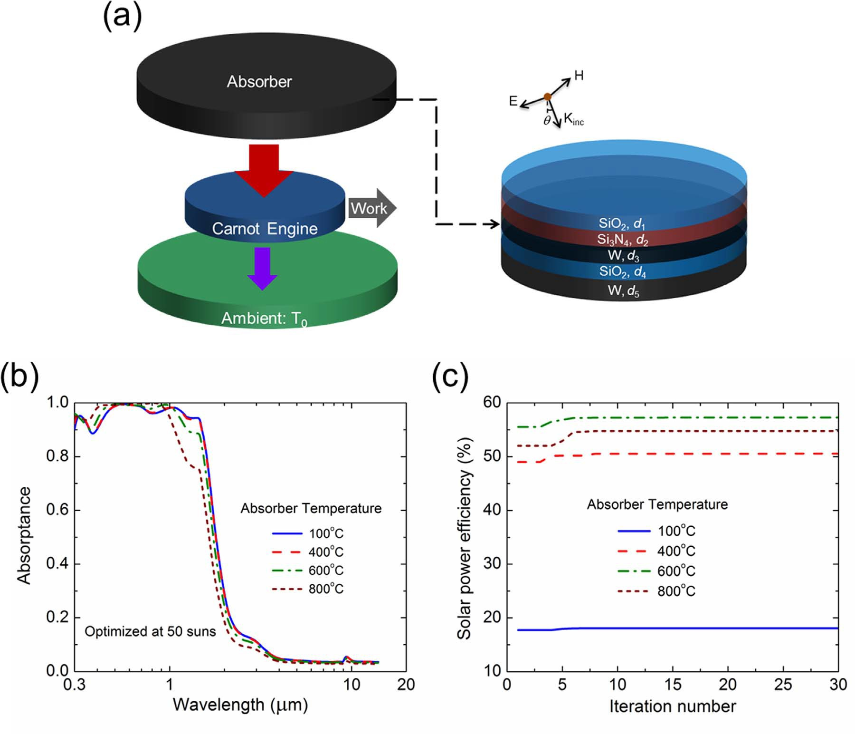

Fig. 1. (a) An illustration of a solar thermal power system with a Carnot heat engine, as well as the schematic of the proposed multilayer selective solar absorber; (b) Calculated spectral- normal absorptance of optimized multilayer solar absorbers at diﬀerent temperatures; (c) Calculated maximum solar-to-power eﬃciency with optimized multilayer solar absorbers.

4 4

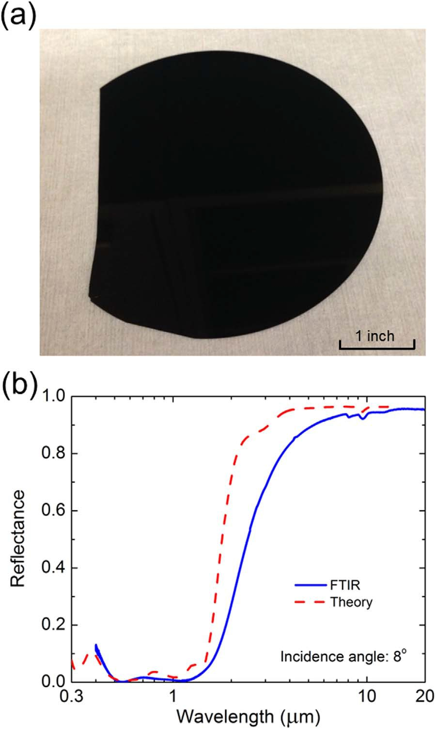

*η*solar−power = *η*solar−thermal × *η*carnot =

*αCG* − *εσ* (*T*A − *T*0 )

*CG*

*T*0

× (1 − )

*T*A

(1)

where *η*solar−thermal is the solar-to-thermal eﬃciency, *η*carnot = 1 − *T*0/*T*A

is the eﬃciency of a Carnot heat engine, *C* is the concentration factor, *G*

= 1000 W/m2 is the total solar radiative heat ﬂux at AM 1.5 (global tilt) [38], *σ* is the Stefan-Boltzmann constant, *T*A is the absorber tem- perature, and *T*0 is the environment temperature (i.e., 300 K). *α* and *ε* are respectively the total-hemispherical absorptance and emittance in- tegrated over the entire spectral range:

*α* ≈ *α*N = ∫0

∞ ∞

*αλ*′,N *G*AM1 .5 (*λ*)*dλ*/ ∫0

*G*AM1 .5 (*λ*)*dλ*

(2)

*ε* ≈ *ε*N = ∫0

∞ ∞

*ελ*′,N *I*BB (*λ*, *T*A)*dλ*/ ∫0

*I*BB (*λ*, *T*A)*dλ*

(3)

where *G*AM1 .5 is the spectral intensity of solar radiation at AM1.5 (global tilt), *I*BB (*λ*, *T*A) is the spectral blackbody radiative intensity at the solar absorber temperature of *T*A, *αλ*′,N and *ελ*′,*N* are respectively the spectral normal absorptance and emittance of the solar absorber. According to Kirchhoﬀ's law, *αλ*′,N = *ελ*′,*N* , which are to be obtained either from spectrometric measurements or theoretical modeling. Here, to simply the calculation, both α and ε are considered to be independent on the incidence angle such that *α* ≈ *α*N and *ε* ≈ *ε*N, while the diﬀuse behavior of the multilayer selective absorber will be conﬁrmed later by the op-

tical characterization at oblique directions. The spectral integration range is from 0.3 to 14 µm for the calculation of *α* and *ε* due to the limited data for the optical constants obtained from Palik [39], which covers 97% energy of solar radiation and 98% energy of thermal ra- diation for an absorber at 1000 °C.

Fig. 1b shows the spectral absorptance for the selective solar ab- sorber calculated with the transfer matrix method [40], with the thickness for each layer optimized with the PSO method at 50 suns (i.e., *C* = 50) and the absorber temperatures *T*A = 100 °C, 400 °C, 600 °C and 800 °C. It is observed that after 30 iterations, the optimized solar absorbers exhibit excellent spectral selectivity with solar absorptance α > 0.95 in the solar spectrum and thermal emittance ε < 0.05 in the IR range. It is also noticed that the absorption band blue shifts to shorter wavelengths for optimized absorbers at higher temperatures. This is because as the absorber temperature increases, the peak for spectral blackbody intensity will blue shift based on Wien's displacement law. Therefore, the absorption band (i.e. emission band) for the solar ab- sorber needs to blue shift as well to suppress the total thermal emit- tance. Fig. 1c is the solar-to-power conversion eﬃciency for the opti- mized solar absorbers at diﬀerent temperatures. It is observed that the solar-to-power eﬃciency with the proposed multilayer solar absorbers reaches the maxima of 18.1%, 50.6%, 57.3% and 54.8% respectively at

*T*A = 100 °C, 400 °C, 600 °C and 800 °C.

* 1. *Sample fabrication*

The multilayer solar absorber optimized at *T*A = 400 °C was se- lected for sample fabrication and experimental characterizations, while the targeted thicknesses for each layer along with fabrication methods and key parameters like deposition rate, chamber pressure and

Fig. 2. (a) A photo of the fabricated multilayer selective solar absorber on a 4-in. silicon wafer-; (b) Spectral directional (specular) reﬂectance characterized by the FTIR at an incidence angle of 8° (unpolarized).

temperature are speciﬁed in Table 1. The bottom W-SiO2-W stack was fabricated by sputtering (Lesker PVD75 Sputter Coater), while the top thin SiO2 and Si3N4 layers were deposited with chemical vapor de- position (Plasma Quest RPCVD) for better quality in order to serve as an oxygen passivation layer under heating in air. Note that the entire ul- trathin multilayer stack is around 400 nm in thickness. Fig. 2(a) shows a photo for the multilayer solar absorber fabricated on a 4-in. silicon wafer, which appears black indicating its high absorptance in the visible spectral regime. Note that the multilayer absorber has zero transmission as the bottom 200-nm tungsten layer is optically opaque,

Table 1

Deposition method and parameters for diﬀerent layers in the proposed multilayer selective solar absorber.

|  |  |  |  |  |  |  |
| --- | --- | --- | --- | --- | --- | --- |
| Material | Deposition method | Layer thickness (nm) | Deposition rate (Å/s) | Base pressure (10−6 Torr) | Chamber temperature (°C) | Sputtering or RF power (W) |
| SiO2 top layer | CVD | 73 | ~1.1 | – | 300 | – |
| Si3N4 | CVD | 50 | ~0.7 | – | 300 | – |
| W | RF Sputtering | 10 | 0.4 | 2 | – | 35 |
| thin ﬁlm |  |  |  |  |  |  |
| SiO2 cavity | DC Sputtering | 71 | 0.65 | 2 | – 200 | |
| W substrate | DC Sputtering | 200 | 1.2 | 2 | – 100 | |

1. Results and discussion

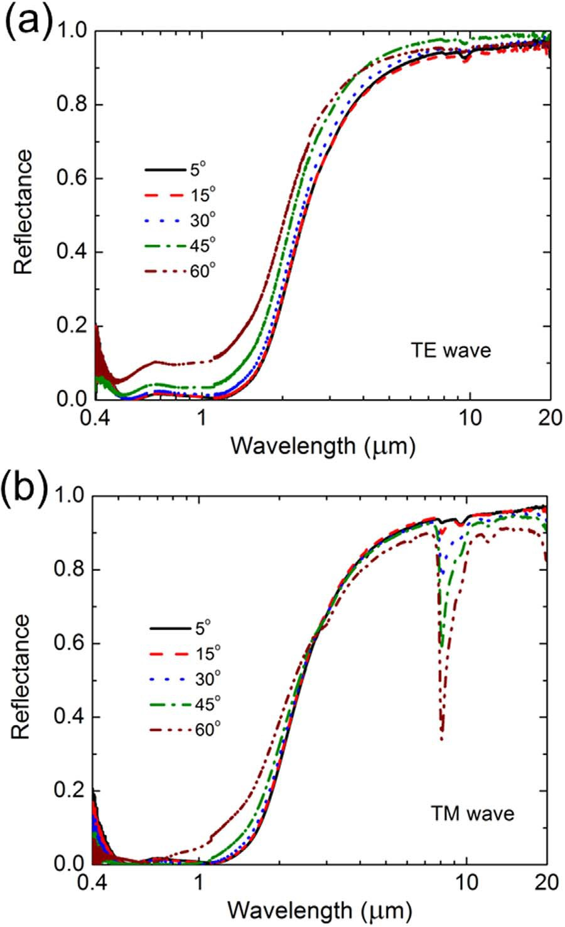

* 1. *Wavelength-selective optical and radiative properties at room temperature*

The specular spectral directional reﬂectance *R*′*λ*

*sp*

of the fabricated

multilayer absorber was characterized by an FTIR spectrometer

(Thermo Scientiﬁc, iS50) at an incidence angle of 8° with a variable- angle reﬂectance accessory (Harrick, Seagull) in wavelength from 0.4 to 20 µm with a resolution of 4 cm−1 in wavenumber. The visible and NIR reﬂectance (i.e., 0.4 µm < λ < 1 µm) was measured by a Si detector, while a deuterated triglycine sulfate (DTGS) detector was employed for the mid-IR measurement (i.e., 1 µm < λ < 20 µm). Each measurement spectrum was averaged from 32 scans with an Al mirror as the re- ference, and the measured reﬂectance was corrected by the theoretical reﬂectance of Al. Fig. 2b plots the specular spectral-normal reﬂectance measured by the FTIR as well as the theoretical reﬂectance for com- parison. A good match between theory and measurement can be ob- served in the visible and NIR spectral regime, while the measured re- ﬂectance is a bit lower for 2 µm < λ < 10 µm, which is most probably due to impurities during fabrication. The fabricated sample exhibits

*sp*

specular reﬂectance

*sp*

*Rλ*′

< 0.03 within 0.5 µm < λ < 1.2 µm, and

*Rλ*′

> 0.9 in the mid-IR at λ > 5 µm.

* 1. *Quasi-diﬀuse absorption or emission from directional characterization*

In addition to spectral selectivity, an ideal solar absorber should also exhibit consistent performance at various incidence angles to harvest most sunlight incident from oblique directions. In order to investigate the angular dependence of the selective multilayer solar absorber, its

*sp*

specular reﬂectance *Rλ*′

was measured at oblique incidence angles with

the FTIR. Note that the optical behavior may vary under diﬀerent po- larizations at oblique incidences. Therefore, the measurement was performed separately for transverse electric (TE) and transverse mag- netic (TM) incidences. A TE wave represents an incident wave with an electric ﬁeld perpendicular to the plane of incidence spanned by the incident wavevector and surface normal, while a TM wave indicates that the wave magnetic ﬁeld is perpendicular to the plane of incidence. The linearly polarized incident wave was obtained using a broadband

Fig. 3. Spectral directional (specular) reﬂectance characterized by the FTIR at various oblique incidences for (a) TE waves and (b) TM waves.

reﬂectance. As our FTIR reﬂectance accessory only measures the spec- ular reﬂectance *R*′*sp*, the spectral directional-hemispherical reﬂectance

polarizer (Thorlabs, WP25M-UB) in the visible and NIR regime and the

*Rλ*′∩

*λ*

has to be characterized to evaluate the solar absorption and thermal

FTIR internal wire-grid polarizer in the mid-IR range.

The measured specular reﬂectance with oblique incidence at both TE and TM polarizations is shown in Fig. 3, for incidence angles of 5°, 15°, 30°, 45° and 60°. From Fig. 3(a) which shows the measurement for TE incidence, the reﬂectance barely changes at incidence angles up to 45° in the entire wavelength range, but slightly increases up to around

0.1 at the incidence angle of 60° in the visible and NIR spectral regime. On the other hand, the reﬂectance of this selective solar absorber barely changes in the visible and NIR range for TM incidence, but exhibits a reﬂection dip around λ = 8 µm whose reﬂectance decreases down to

0.3 when the incidence angle increases up to 60°. This reﬂection dip is

due to the Berreman leaky mode [41,42] within the phonon band of SiO2, where it is lossy due to the strong absorption caused by lattice vibrations. Note that the Berreman mode can only be excited for TM incidence. Overall, the spectral reﬂectance of the proposed multilayer sample is insensitive to the incidence angle at most wavelengths with incidence angle up to 45° for both TM and TE polarizations. In other words, the multilayer solar absorber exhibits quasi-diﬀuse absorption or emission behaviors.

* 1. *High specularity from spectral directional-hemispherical reﬂectance measurements*

Note that spectral directional absorptance or emittance of the multilayer solar absorber is calculated by *aλ*′ = *ελ*′ = 1−*Rλ*′∩ based on energy balance, where *Rλ*′∩ is the spectral directional-hemispherical

emission as well as the contribution due to diﬀusely reﬂected light, especially when heated up in air. A tunable light source assembly (Newport, TLS-250QU), including a Quartz Tungsten Halogen lamp source (Newport, 6334NS), a monochromator (Newport, CS130-USB-3- FH), as well as an optical chopper (Newport, 75163) and a lock-in ampliﬁer (Newport, Merlin), was used to perform the hemispherical and diﬀuse reﬂectance measurements. The sample was mounted at the back of an 8-in. integration sphere (Labsphere, CSTM-R/T) to measure the spectral directional-hemispherical or diﬀuse reﬂectance at an in- cidence angle of 8°. A light trap was employed to absorb the specular component of reﬂected light in order to measure the diﬀuse reﬂectance. The spectral measurement within 0.4 µm < λ < 1 µm was performed utilizing a Si detector (Thorlabs, SM05PD1A), while the measurement from 1 µm to 1.6 µm employed an InGaAs (Thorlabs, SM05PD5A) de- tector. An Al mirror was used as the reference and the measured re-

ﬂectance was corrected based on the theoretical reﬂectance of Al. Both the hemispherical and diﬀuse reﬂectance was measured for the multi- layer absorber sample before and after being heated at 600 °C for an hour in air.

Fig. 4a shows the measurement results for the multilayer solar ab- sorber sample before heating. It can be found that the diﬀuse re- ﬂectance is negligible, indicating excellent specularity of this multilayer absorber, which is expected for a planar multilayer structure without

nano-structured surfaces. The hemispherical reﬂectance *Rλ*′∩ is also plotted for comparison with the specular reﬂectance *R*′*sp* measured by

*λ*

by the same ﬁber head and guided back to the FTIR detector through the other ﬁber leg. Meanwhile, the multilayer absorber sample was placed in a customized heater for heating in air. A thermocouple (Omega, KMTXL-040) was employed to monitor the sample tempera- ture, while a temperature controller (Omega, CSi8D) was utilized to maintain the sample temperature at its setpoint. The sample tempera- ture was stabilized at its setpoint for at least 30 min before each mea- surement. The spectral measurement was performed from 0.45 to 18 µm in wavelength, and the results were averaged from 100 scans with a resolution of 16 cm−1. An Al mirror was used to measure the reference signal *S*ref, and the sample signal *S*sample was measured as the signal reﬂected from the sample surface. Note that the noise signal needs to be corrected as the ﬁber head will directly reﬂect part of the signal, which is neither reﬂected by the Al mirror nor the multilayer absorber sample. Therefore, the noise signal *S*noise was measured with the optical ﬁber facing the ambient background. By correcting the sample reﬂectance with the noise signal and the theoretical reﬂectance of the Al mirror, the actual sample reﬂectance can be obtained by:

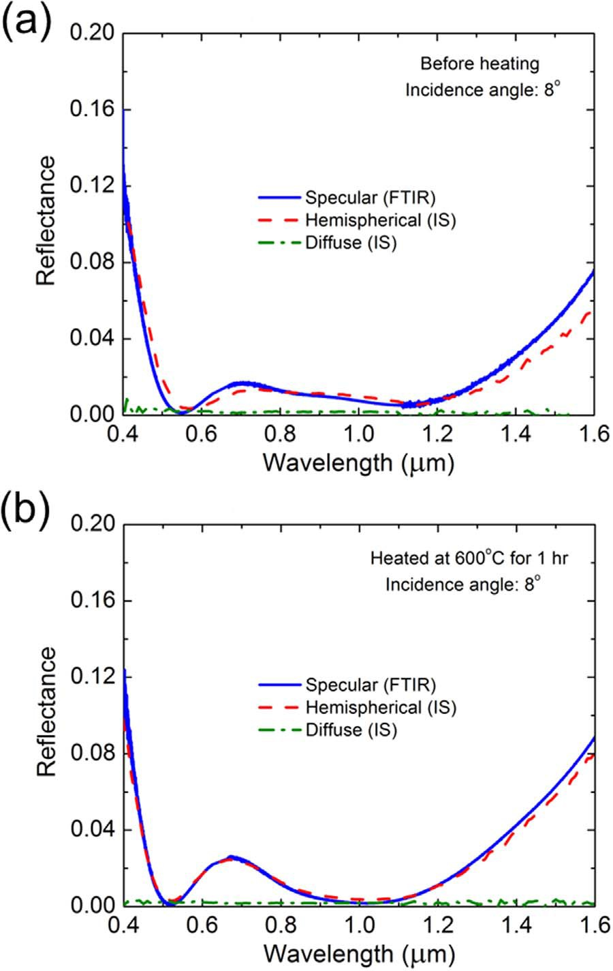

*S*sample − *S*noise

*R*corrected =

*S*ref − *S*noise

× *R*Al (4)

Fig. 4. Spectral directional-hemispherical and diﬀuse reﬂectance characterized by the integrating sphere for the fabricated multilayer selective absorber sample: (a) before heating; (b) after heating at 600 °C for 1 h in air.

Fig. 5a shows the temperature dependent reﬂectance of the multi- layer absorber measured by the FTIR ﬁber optics setup. It can be seen that the reﬂectance of the tested sample barely changes from room temperature to 600 °C, indicating its excellent high temperature stabi- lity. On the other hand, the visible-NIR reﬂectance starts to increase and the IR reﬂectance begins to decrease dramatically when the

the FTIR, which clearly proves *Rλ*′∩ ≈ *Rλ*′

*sp*

due to highly specular surface

within a small diﬀerence less than 2.5%. This also suggests a good agreement between the measurement results from these two methods. As a result, the fabricated solar absorber is demonstrated to be highly absorbing in the solar spectrum while barely emitting in the mid-IR range. In addition, this sample was measured after being heated in a furnace at 600 °C for 1 h with the presence of air in order to examine its specularity after heating. It can be seen from Fig. 4b that the diﬀusely reﬂected light is still negligible after heating, demonstrating that this sample remains highly specular even after being heated at 600 °C in air for an hour. The spectral hemispherical reﬂectance *Rλ*′∩ of the multilayer

absorber has a small change less than 3% before and after heating,

indicating good thermal stability of this multilayer solar absorber.

* 1. *Excellent thermal stability in air from temperature-dependent spectrometric characterization and thermal cycling test*

Consistent optical performance of solar thermal absorbers at ele- vated temperatures is crucial, especially for CSP systems to maintain their high conversion eﬃciency under concentrated solar radiation. In order to study the optical and radiative properties of the multilayer solar absorber at diﬀerent temperatures, a ﬁber optics setup coupled to the FTIR bench was employed for the temperature dependent spectral- normal reﬂectance measurement. An FTIR ﬁber coupler (Harrick, FiberMate2) was utilized to couple the signal from the FTIR internal sources into a visible–NIR (Thorlabs, RP21) or IR (High Tech Photonics, AP10757) Y-shape ﬁber bundle. The incident light was focused onto the sample surface via one ﬁber leg, and the reﬂected signal was collected

Fig. 5. (a) Temperature dependent specular reﬂectance characterized by FTIR ﬁber op- tics. (b) Spectral directional (specular) reﬂectance of the multilayer absorber measured by FTIR at room temperature after multilayer thermal cycle tests at 400 °C in air.

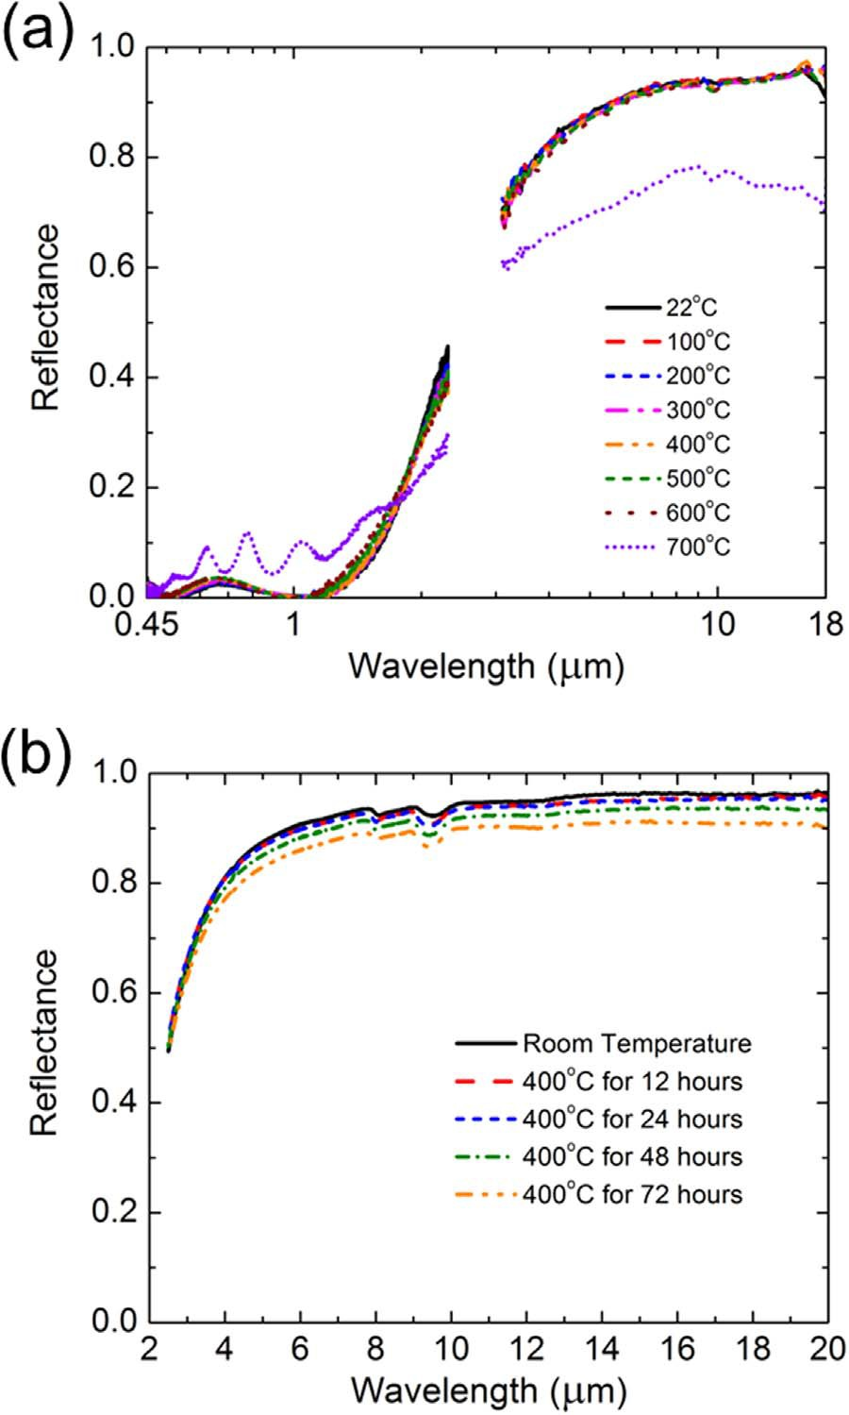

temperature further increases up to 700 °C. This indicates instability possibly caused by physical or chemical changes at that high tem- perature. Note that the spectral-normal reﬂectance within 2.3 µm < λ < 3.1 µm, which is not covered by either the transmission band of the vis-NIR and IR optical ﬁbers, is not shown due to the poor signal-to- noise ratio.

Although the multilayer absorber was demonstrated to possess stable performance up to 600 °C under short-term heating, it still re- mains a question whether it can exhibit good thermal stability in longer heating from alternating heating and cooling cycles. Therefore, a thermal cycle testing was conducted for this multilayer solar absorber sample at 400 °C in a furnace with presence of air. The multilayer ab- sorber went through 1–6 heating/cooling cycles, while each heating/ cooling cycle consists of a heating time of 12 h in furnace followed by 2 h cooling. The IR reﬂectance was measured after each heating/ cooling cycle at room temperature as shown in Fig. 5b. It can be ob- served that the IR reﬂectance barely changes for heating within 24 h. The IR reﬂectance decreases a bit for longer heating but the overall absolute change of IR reﬂectance is within 6%.

* 1. *Failure mechanisms from SEM and RBS characterizations*

As indicated by Fig. 5, the optical and radiative properties of the multilayer solar absorber are stable at temperatures up to 600 °C, but degrade dramatically at 700 °C. In order to understand the reasons that cause the degradation at 700 °C, the sample was characterized under an FE-SEM (Hitachi S4700) before and after heating in air. Figs. 6a and 6b show the SEM images of the sample surface before and after being heated at 600 °C for 1 h, indicating no apparent changes. However, when the sample was further heated at 700 °C in air for 1 h, blisters with diameters around 200 µm were formed at the sample surface as shown in Fig. 6c. Possible reasons for the surface blistering could be the thermal stress due to the coeﬃcient of thermal expansion (CTE) mis- match between the silicon wafer and the tungsten substrate, or the outgassing of helium molecules that were trapped inside the multilayer structure during the CVD process. The surface blistering could be po- tentially avoided by employing materials with better CTE match to reduce thermal stress or by thermal annealing to release the helium molecules.

In addition, Rutherford backscattering (RBS) analysis by impinging a helium ion beam onto the sample and measuring the back scattering condition of ions was carried out to study the chemical compositions and depth information of the multilayer selective absorber sample. Fig. 7 shows the result for the RBS analysis, where each individual peak represents the ions backscattered with a certain energy, indicating the existence of one particular element at a certain depth. It can be ob- served that the RBS results for the multilayer sample before and after being heated at 600 °C are almost identical, conﬁrming its thermal stability at temperatures up to 600 °C. On the other hand, the RBS curve for the sample heated at 700 °C shows a signiﬁcant diﬀerence. The peak associated with the tungsten substrate becomes lower, but expands to the lower energy region towards the bottom left. This phenomenon is due to surface blistering, as when the multilayer blisters up, part of the ions will need to penetrate a longer distance through the tungsten substrate before being scattered. Therefore, these scattered ions exhibit a lower energy due to the higher energy loss while penetrating through a longer distance in the tungsten layer. As a result, less scattered ions

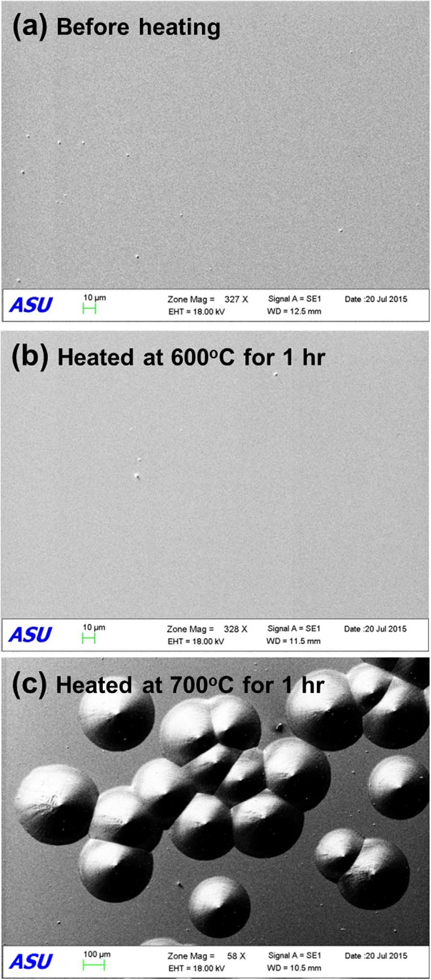

Fig. 6. SEM images of the fabricated multilayer selective solar absorber sample: (a) be- fore heating; (b) after heated at 600 °C for 1 h in air; (c) after heating at 700 °C for 1 h in air.

multilayer selective solar absorber, its solar-to-power eﬃciency was theoretically investigated according to Eq. (1). Since the multilayer absorber was demonstrated to be angular-insensitive as well as ther- mally stable up to 600 °C, its near-normal optical and radiative prop- erties obtained from the room temperature FTIR measurement were

used for the theoretical eﬃciency analysis. Fig. 8a shows the solar-to-

exhibit higher energy and the peak associated with the tungsten sub-

strate will be lower on the high energy end. On the other hand, more

power conversion eﬃciency *η*solar−power

of the ideal, multilayer, and

scattered ions exhibit lower energy and the peak indicating the tungsten substrate will expand to a lower energy region.

* 1. *Predicted solar-to-power eﬃciency with the multilayer selective absorber*

In order to quantitatively evaluate the performance of the

black absorbers as the absorber temperature varies from 100 °C to

800 °C. Note that the concentration factor was ﬁxed at *C* = 5 and the ambient temperature was considered as *T*0 = 20 °C. An ideal absorber has an optimized cutoﬀ wavelength, below which the spectral absorp- tance is unity with zero absorptance elsewhere. On the other hand, a black absorber exhibits unity absorptance or emittance over the entire wavelength range. It is observed from Fig. 8a that the *η*solar−power for the

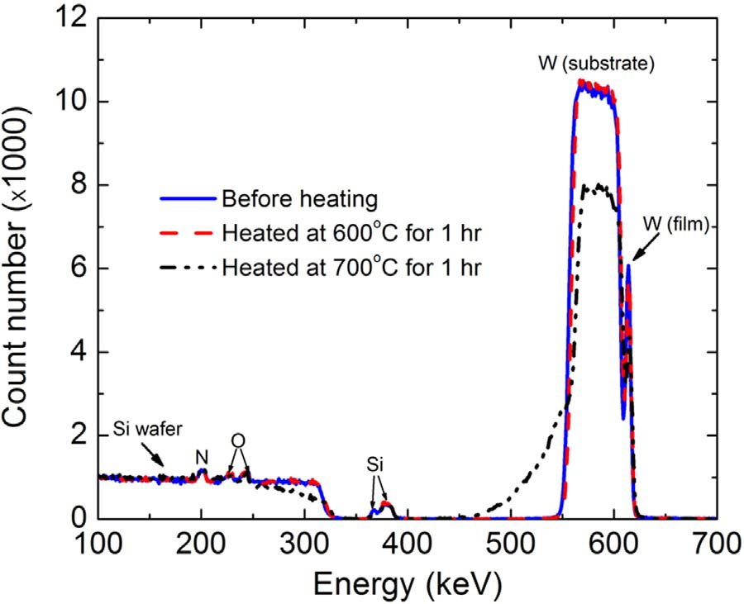

Fig. 7. RBS characterization results of the fabricated multilayer selective solar absorber sample before and after heating at 600 °C or 700 °C for 1 h in air.

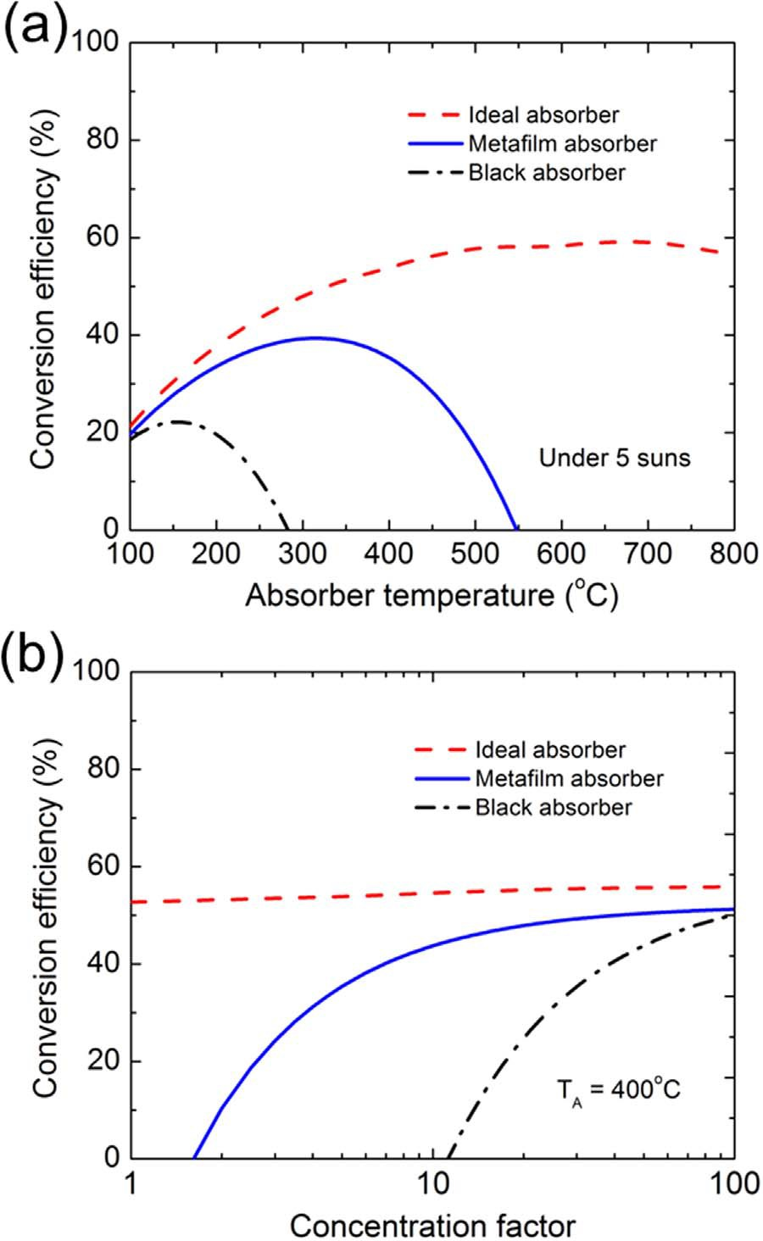

Fig. 8. Theoretical solar-to-power eﬃciencies for the ideal selective absorber, the fabri- cated multilayer selective absorber, and the black absorber when coupled with a Carnot heat engine at: (a) diﬀerent absorber temperatures with a ﬁxed concentration factor of 5;

(b) varied concentration factors with a ﬁxed absorber temperature of 400 °C.

three absorbers are comparable at low absorber temperature *T*A = 100 °C: 21.3% for the ideal absorber, 19.6% for the multilayer absorber, and 18.5% for the black absorber, respectively. There is expected be- cause the thermal re-emission loss is negligible when the absorber temperature is low, hence spectral selectivity to minimize the thermal re-emission loss does not have a noticeable impact on the performance

of the absorber. On the other hand, the three diﬀerent absorbers show remarkably diﬀerent performances when the absorber temperature becomes higher. It is found that the highest solar-to-power eﬃciency for the ideal, multilayer and black absorber are respectively 59.1%, 39.4% and 22.1% but at diﬀerent absorber temperatures. The conver- sion eﬃciency of the multilayer absorber drops to zero at a temperature of 550 °C, or called stagnation temperature where no solar energy is converted to power. On the other hand, the stagnation temperature for the black absorber is much lower at 280 °C. Nevertheless, the conver- sion eﬃciency of the ideal absorber is still as high as 56% when the temperature reaches 800 °C. This demonstrates the importance of spectral selectivity in improving the performance of solar thermal ab- sorbers at high temperatures.

Fig. 8b shows the solar-to-power conversion eﬃciency for the three types of absorber when the concentration factor varies from 1 to 100 at the ﬁxed absorber temperature *T*A = 400 °C. It can be observed that the solar-to-power conversion eﬃciency increases with a higher con- centration factor, since the energy loss through thermal re-emission will be relatively smaller when compared with a larger input solar radiation. It is also found that the diﬀerence between the eﬃciency of the three absorbers is large at smaller concentration factors, but becomes less signiﬁcant as the concentration factor increases. This is because spectral selectivity is less important at larger concentration factors when the thermal re-emission loss becomes negligible. The multilayer absorber could convert 40% of solar radiation into power under 5 suns, 42% under 10 suns, and 51% under 100 suns, but none when the con- centration is below 1.6 suns. In comparison, at least of 10.5 suns con- centration is required for the black absorber to obtain nonzero power from sunlight.

1. Conclusions

In this work, a multilayer selective solar absorber made of SiO2- Si3N4-W-SiO2-W stacks was theoretically designed, experimentally fabricated, and optically characterized. FTIR measurements indicate excellent spectral selectivity from this multilayer absorber with solar absorptance larger than 0.95 in the visible and near IR, as well as emittance less than 0.1 in the IR spectral regime. Oblique reﬂectance was also characterized by the FTIR for both TE and TM polarizations, demonstrating its insensitivity to incidence angles. On the other hand, the diﬀuse reﬂectance was measured in the integrating sphere coupled with a tunable light source, indicating high specularity of this multi- layer absorber both before and after being heated at 600 °C. In addition, high temperature stability was investigated by the temperature de- pendent reﬂectance measurement with FTIR ﬁber optics, proving its excellent thermal stability up to 600 °C in air. Thermal cycling test revealed that the developed multilayer selective absorber is thermally stable at 400 °C for up to 72 h heating in air. In order to investigate the causes for the thermal degradation above 600 °C, the sample was characterized by both SEM and RBS techniques after being heated at 700 °C, where surface blistering is observed to be responsible for the change of optical properties at higher temperatures. The surface blis- tering, which is possibly due to CTE mismatch or outgassing from the structure, could be further avoided by better material selection and fabrication procedures for possible better thermal stability above 600 °C. Theoretical eﬃciency analysis was also performed for the de- veloped multilayer selective absorber, indicating its overwhelming conversion eﬃciency compared with a black surface, while there is still room for improvement to approach to the performance of the ideal absorber. The insights gained from this work will facilitate the research and development of novel selective solar thermal absorbers with ex- cellent spectral selectivity and thermal stability at high temperatures to boost the performances in various solar thermal power systems.

Acknowledgements

This work was mainly supported by the National Science Foundation under Grant number CBET-1454698 (L.W.) and the US- Australia Solar Energy Collaboration - Micro Urban Solar Integrated Concentrators (MUSIC) project sponsored by the Australian Renewable Energy Agency (H.W.). H.A. would like to thank King Saud University and the Saudi Arabian Cultural Mission (SACM) for their sponsorship for his Ph.D. study at ASU. We would like to thank ASU Center for Solid State Electronics Research to provide cleanroom facility for sample fabrication and ASU LeRoy Eyring Center for Solid State Science to use the Ion Beam Analysis of Materials facility for the SEM and RBS char- acterizations.

References

[1] [I.E. Khodasevych, L. Wang, A. Mitchell, G. Rosengarten, Micro and nanostructured](http://refhub.elsevier.com/S0927-0248(17)30516-0/sbref1) [surfaces for selective solar absorption, Adv. Opt. Mater. 3 (2015) 852–881.](http://refhub.elsevier.com/S0927-0248(17)30516-0/sbref1)

[2] [R. Pettit, R. Sowell, I. Hall, Black chrome solar selective coatings optimized for high](http://refhub.elsevier.com/S0927-0248(17)30516-0/sbref2) [temperature applications, Sol. Energy Mater. 7 (1982) 153–170.](http://refhub.elsevier.com/S0927-0248(17)30516-0/sbref2)

[3] [G.E. Mcdonald, Spectral re](http://refhub.elsevier.com/S0927-0248(17)30516-0/sbref3)ﬂ[ectance properties of black chrome for use as a solar](http://refhub.elsevier.com/S0927-0248(17)30516-0/sbref3) [selective coating, Sol. Energy 17 (1975) 119–122.](http://refhub.elsevier.com/S0927-0248(17)30516-0/sbref3)

[4] [J. Sweet, R. Pettit, M. Chamberlain, Optical modeling and aging characteristics of](http://refhub.elsevier.com/S0927-0248(17)30516-0/sbref4) [thermally stable black chrome solar selective coatings, Sol. Energy Mater. 10 (1984)](http://refhub.elsevier.com/S0927-0248(17)30516-0/sbref4) [251–286.](http://refhub.elsevier.com/S0927-0248(17)30516-0/sbref4)

[5] [C.K. Ho, A.R. Mahoney, A. Ambrosini, M. Bencomo, A. Hall, T.N. Lambert,](http://refhub.elsevier.com/S0927-0248(17)30516-0/sbref5) [Characterization of Pyromark 2500 paint for high-temperature solar receivers, J.](http://refhub.elsevier.com/S0927-0248(17)30516-0/sbref5) [Sol. Energy Eng. 136 (2014) 014502.](http://refhub.elsevier.com/S0927-0248(17)30516-0/sbref5)

[6] [D. Ding, W. Cai, Self-assembled nanostructured composites for solar absorber,](http://refhub.elsevier.com/S0927-0248(17)30516-0/sbref6) [Mater. Lett. 93 (2013) 269–271.](http://refhub.elsevier.com/S0927-0248(17)30516-0/sbref6)

[7] [L. Gaouyat, Z. He, J.-F. Colomer, P. Lambin, F. Mirabella, D. Schryvers, O. Deparis,](http://refhub.elsevier.com/S0927-0248(17)30516-0/sbref7) [Revealing the innermost nanostructure of sputtered Nicro X solar absorber cermets,](http://refhub.elsevier.com/S0927-0248(17)30516-0/sbref7) [Sol. Energy Mater. Sol. Cells 122 (2014) 303–308.](http://refhub.elsevier.com/S0927-0248(17)30516-0/sbref7)

[8] [E. Wäckelgård, A. Mattsson, R. Bartali, R. Gerosa, G. Gottardi, F. Gustavsson,](http://refhub.elsevier.com/S0927-0248(17)30516-0/sbref8)

[N. Laidani, V. Micheli, D. Primetzhofer, B. Rivolta, Development of W–SiO2 and](http://refhub.elsevier.com/S0927-0248(17)30516-0/sbref8) [Nb–TiO2 solar absorber coatings for combined heat and power systems at inter-](http://refhub.elsevier.com/S0927-0248(17)30516-0/sbref8) [mediate operation temperatures, Sol. Energy Mater. Sol. Cells 133 (2015) 180–193.](http://refhub.elsevier.com/S0927-0248(17)30516-0/sbref8)

[9] [J. Cheng, C. Wang, W. Wang, X. Du, Y. Liu, Y. Xue, T. Wang, B. Chen, Improvement](http://refhub.elsevier.com/S0927-0248(17)30516-0/sbref9) [of thermal stability in the solar selective absorbing Mo–Al2O3 coating, Sol. Energy](http://refhub.elsevier.com/S0927-0248(17)30516-0/sbref9) [Mater. Sol. Cells 109 (2013) 204–208.](http://refhub.elsevier.com/S0927-0248(17)30516-0/sbref9)

[10] [Q.-C. Zhang, Stainless-steel–AlN cermet selective surfaces deposited by direct cur-](http://refhub.elsevier.com/S0927-0248(17)30516-0/sbref10) [rent magnetron sputtering technology, Sol. Energy Mater. Sol. Cells 52 (1998)](http://refhub.elsevier.com/S0927-0248(17)30516-0/sbref10) [95–106.](http://refhub.elsevier.com/S0927-0248(17)30516-0/sbref10)

[11] [L. Tang, F. Cao, Y. Li, J. Bao, Z. Ren, High performance mid-temperature selective](http://refhub.elsevier.com/S0927-0248(17)30516-0/sbref11) [absorber based on titanium oxides cermet deposited by direct current reactive](http://refhub.elsevier.com/S0927-0248(17)30516-0/sbref11) [sputtering of a single titanium target, J. Appl. Phys. 119 (2016) 045102.](http://refhub.elsevier.com/S0927-0248(17)30516-0/sbref11)

[12] [Y. Liu, X. Zhang, Metamaterials: a new frontier of science and technology, Chem.](http://refhub.elsevier.com/S0927-0248(17)30516-0/sbref12)

[Soc. Rev. 40 (2011) 2494–2507.](http://refhub.elsevier.com/S0927-0248(17)30516-0/sbref12)

[13] [H. Wang, L. Wang, Perfect selective metamaterial solar absorbers, Opt. Express 21](http://refhub.elsevier.com/S0927-0248(17)30516-0/sbref13) [(2013) A1078–A1093.](http://refhub.elsevier.com/S0927-0248(17)30516-0/sbref13)

[14] [L. Wang, Z. Zhang, Wavelength-selective and diﬀuse emitter enhanced by magnetic](http://refhub.elsevier.com/S0927-0248(17)30516-0/sbref14) [polaritons for thermophotovoltaics, Appl. Phys. Lett. 100 (2012) 063902.](http://refhub.elsevier.com/S0927-0248(17)30516-0/sbref14)

[15] [H. Wang, V.P. Sivan, A. Mitchell, G. Rosengarten, P. Phelan, L. Wang, Highly ef-](http://refhub.elsevier.com/S0927-0248(17)30516-0/sbref15) ﬁ[cient selective metamaterial absorber for high-temperature solar thermal energy](http://refhub.elsevier.com/S0927-0248(17)30516-0/sbref15) [harvesting, Sol. Energy Mater. Sol. Cells 137 (2015) 235–242.](http://refhub.elsevier.com/S0927-0248(17)30516-0/sbref15)

[16] [B.J. Lee, Y.-B. Chen, S. Han, F.-C. Chiu, H.J. Lee, Wavelength-selective solar thermal](http://refhub.elsevier.com/S0927-0248(17)30516-0/sbref16) [absorber with two-dimensional nickel gratings, J. Heat Transf. 136 (2014) 072702.](http://refhub.elsevier.com/S0927-0248(17)30516-0/sbref16)

[17] [S. Han, J.H. Shin, P.H. Jung, H. Lee, B.J. Lee, Broadband solar thermal absorber](http://refhub.elsevier.com/S0927-0248(17)30516-0/sbref17) [based on optical metamaterials for high temperature applications, Adv. Opt. Mater.](http://refhub.elsevier.com/S0927-0248(17)30516-0/sbref17)

[4 (2016) 1265–1273.](http://refhub.elsevier.com/S0927-0248(17)30516-0/sbref17)

[18] [W. Wang, Y. Qu, K. Du, S. Bai, J. Tian, M. Pan, H. Ye, M. Qiu, Q. Li, Broadband](http://refhub.elsevier.com/S0927-0248(17)30516-0/sbref18) [optical absorption based on single-sized metal-dielectric-metal plasmonic nanos-](http://refhub.elsevier.com/S0927-0248(17)30516-0/sbref18) [tructures with high-ε metals, Appl. Phys. Lett. 110 (2017) 101101.](http://refhub.elsevier.com/S0927-0248(17)30516-0/sbref18)

[19] [J. Dai, F. Ye, Y. Chen, M. Muhammed, M. Qiu, M. Yan, Light absorber based on](http://refhub.elsevier.com/S0927-0248(17)30516-0/sbref19) [nano-spheres on a substrate reﬂector, Opt. Express 21 (2013) 6697–6706.](http://refhub.elsevier.com/S0927-0248(17)30516-0/sbref19)

[20] [M. Yan, J. Dai, M. Qiu, Lithography-free broadband visible light absorber based on](http://refhub.elsevier.com/S0927-0248(17)30516-0/sbref20) [a mono-layer of gold nanoparticles, J. Opt. 16 (2014) 025002.](http://refhub.elsevier.com/S0927-0248(17)30516-0/sbref20)

[21] [H. Wang, K. O’dea, L. Wang, Selective absorption of visible light in](http://refhub.elsevier.com/S0927-0248(17)30516-0/sbref21) ﬁ[lm-coupled](http://refhub.elsevier.com/S0927-0248(17)30516-0/sbref21) [nanoparticles by exciting magnetic resonance, Opt. Lett. 39 (2014) 1457–1460.](http://refhub.elsevier.com/S0927-0248(17)30516-0/sbref21)

[22] [V. Stelmakh, V. Rinnerbauer, R. Geil, P. Aimone, J. Senkevich, J. Joannopoulos,](http://refhub.elsevier.com/S0927-0248(17)30516-0/sbref22)

[M. Soljačić, I. Celanovic, High-temperature tantalum tungsten alloy photonic](http://refhub.elsevier.com/S0927-0248(17)30516-0/sbref22) [crystals: stability, optical Properties, and fabrication, Appl. Phys. Lett. 103 (2013)](http://refhub.elsevier.com/S0927-0248(17)30516-0/sbref22) [123903.](http://refhub.elsevier.com/S0927-0248(17)30516-0/sbref22)

[23] [I. Celanovic, N. Jovanovic, J. Kassakian, Two-dimensional tungsten photonic](http://refhub.elsevier.com/S0927-0248(17)30516-0/sbref23) [crystals as selective thermal emitters, Appl. Phys. Lett. 92 (2008) 193101.](http://refhub.elsevier.com/S0927-0248(17)30516-0/sbref23)

[24] [V. Rinnerbauer, S. Ndao, Y.X. Yeng, J.J. Senkevich, K.F. Jensen, J.D. Joannopoulos,](http://refhub.elsevier.com/S0927-0248(17)30516-0/sbref24)

[M. Soljačić, I. Celanovic, R.D. Geil, Large-area fabrication of high aspect ratio](http://refhub.elsevier.com/S0927-0248(17)30516-0/sbref24) [tantalum photonic crystals for high-temperature selective emitters, J. Vac. Sci.](http://refhub.elsevier.com/S0927-0248(17)30516-0/sbref24) [Technol. B 31 (2013) 011802.](http://refhub.elsevier.com/S0927-0248(17)30516-0/sbref24)

[25] [P. Li, B. Liu, Y. Ni, K.-K. Liew, J. Sze, S. Chen, S. Shen, Large-scale nanophotonic](http://refhub.elsevier.com/S0927-0248(17)30516-0/sbref25) [solar selective absorbers for high-e](http://refhub.elsevier.com/S0927-0248(17)30516-0/sbref25)ﬃ[ciency solar thermal energy conversion, Adv.](http://refhub.elsevier.com/S0927-0248(17)30516-0/sbref25) [Mater. 27 (2015) 4585–4591.](http://refhub.elsevier.com/S0927-0248(17)30516-0/sbref25)

[26] [D. Jiang, W. Yang, A. Tang, A refractory selective solar absorber for high perfor-](http://refhub.elsevier.com/S0927-0248(17)30516-0/sbref26) [mance thermochemical steam reforming, Appl. Energy 170 (2016) 286–292.](http://refhub.elsevier.com/S0927-0248(17)30516-0/sbref26)

[27] [M.G. Nielsen, A. Pors, O. Albrektsen, S.I. Bozhevolnyi, E](http://refhub.elsevier.com/S0927-0248(17)30516-0/sbref27)ﬃ[cient absorption of visible](http://refhub.elsevier.com/S0927-0248(17)30516-0/sbref27) [radiation by gap plasmon resonators, Opt. Express 20 (2012) 13311–13319.](http://refhub.elsevier.com/S0927-0248(17)30516-0/sbref27)

[28] [K. Chen, R. Adato, H. Altug, Dual-band perfect absorber for multispectral plasmon-](http://refhub.elsevier.com/S0927-0248(17)30516-0/sbref28) [enhanced infrared spectroscopy, ACS Nano 6 (2012) 7998–8006.](http://refhub.elsevier.com/S0927-0248(17)30516-0/sbref28)

[29] [M. Langlais, H. Bru, P. Ben-Abdallah, High temperature layered absorber for](http://refhub.elsevier.com/S0927-0248(17)30516-0/sbref29) [thermo-solar systems, J. Quant. Spectrosc. Radiat. Transf. 149 (2014) 8–15.](http://refhub.elsevier.com/S0927-0248(17)30516-0/sbref29)

[30] [Z. Nuru, M. Msimanga, C. Arendse, M. Maaza, Heavy ion elastic recoil detection](http://refhub.elsevier.com/S0927-0248(17)30516-0/sbref30) [analysis of AlxOy/Pt/AlxOy multilayer selective solar absorber, Appl. Surf. Sci. 298](http://refhub.elsevier.com/S0927-0248(17)30516-0/sbref30) [(2014) 176–181.](http://refhub.elsevier.com/S0927-0248(17)30516-0/sbref30)

[31] [A. Soum-Glaude, A. Le Gal, M. Bichotte, C. Escape, L. Dubost, Optical character-](http://refhub.elsevier.com/S0927-0248(17)30516-0/sbref31) [ization of TiAlNx/TiAlNy/Al2O3 tandem solar selective absorber coatings, Sol.](http://refhub.elsevier.com/S0927-0248(17)30516-0/sbref31)

[Energ. Mater. Sol. Cells 170 (2017) 254–262.](http://refhub.elsevier.com/S0927-0248(17)30516-0/sbref31)

[32] [A. Dan, J. Jyothi, K. Chattopadhyay, H.C. Barshilia, B. Basu, Spectrally selective](http://refhub.elsevier.com/S0927-0248(17)30516-0/sbref32) [absorber coating of WAlN/WAlON/Al2O3 for solar thermal applications, Sol. Energ.](http://refhub.elsevier.com/S0927-0248(17)30516-0/sbref32) [Mater. Sol. Cells 157 (2016) 716–726.](http://refhub.elsevier.com/S0927-0248(17)30516-0/sbref32)

[33] [A. Dan, K. Chattopadhyay, H.C. Barshilia, B. Basu, Thermal stability of WAlN/](http://refhub.elsevier.com/S0927-0248(17)30516-0/sbref33) [WAlON/Al2O3 based solar selective absorber coating, MRS Adv. 1 (2016)](http://refhub.elsevier.com/S0927-0248(17)30516-0/sbref33) [2807–2813.](http://refhub.elsevier.com/S0927-0248(17)30516-0/sbref33)

[34] [H. Liu, T. Fu, M. Duan, Q. Wan, Y. Chen, D. Fu, F. Ren, Q. Li, X. Cheng, B. Yang,](http://refhub.elsevier.com/S0927-0248(17)30516-0/sbref34) [Structure and thermal stability of spectrally selective absorber based on AlCrON](http://refhub.elsevier.com/S0927-0248(17)30516-0/sbref34) [coating for solar-thermal conversion applications, Sol. Energ. Mater. Sol. Cells 157](http://refhub.elsevier.com/S0927-0248(17)30516-0/sbref34) [(2016) 108–116.](http://refhub.elsevier.com/S0927-0248(17)30516-0/sbref34)

[35] [L. Wang, S. Basu, Z. Zhang, Direct measurement of thermal emission from a](http://refhub.elsevier.com/S0927-0248(17)30516-0/sbref35) [Fabry–Perot cavity resonator, J. Heat Transf. 134 (2012) 072701.](http://refhub.elsevier.com/S0927-0248(17)30516-0/sbref35)

[36] [J. Robinson, Y. Rahmat-Samii, Particle swarm optimization in electromagnetics,](http://refhub.elsevier.com/S0927-0248(17)30516-0/sbref36) [IEEE Trans. Antenn. Prop. 52 (2004) 397–407.](http://refhub.elsevier.com/S0927-0248(17)30516-0/sbref36)

[37] [N. Jin, Y. Rahmat-Samii, Advances in particle swarm optimization for antenna](http://refhub.elsevier.com/S0927-0248(17)30516-0/sbref37) [designs: real-number, binary, single-objective and multiobjective implementations,](http://refhub.elsevier.com/S0927-0248(17)30516-0/sbref37) [IEEE Trans. Antenn. Prop. 55 (2007) 556–567.](http://refhub.elsevier.com/S0927-0248(17)30516-0/sbref37)

[38] Air Mass 1.5 Spectra, American Society for Testing and Materials (ASTM), Available from: 〈<http://rredc.nrel.gov/solar/spectra/am1.5/>〉.

[39] [E.D. Palik, Handbook of Optical Constants of Solids, Academic press, San Diego, CA,](http://refhub.elsevier.com/S0927-0248(17)30516-0/sbref38) [1998.](http://refhub.elsevier.com/S0927-0248(17)30516-0/sbref38)

[40] [Z.M. Zhang, Nano/microscale Heat Transfer, McGraw-Hill, New York, 2007.](http://refhub.elsevier.com/S0927-0248(17)30516-0/sbref39) [41] [S. Vassant, J.-P. Hugonin, F. Marquier, J.-J. Gre](http://refhub.elsevier.com/S0927-0248(17)30516-0/sbref40)ﬀ[et, Berreman mode and epsilon](http://refhub.elsevier.com/S0927-0248(17)30516-0/sbref40)

[near zero mode, Opt. Express 20 (2012) 23971–23977.](http://refhub.elsevier.com/S0927-0248(17)30516-0/sbref40)

[42] [Y.-B. Chen, F.-C. Chiu, Trapping mid-infrared rays in a lossy](http://refhub.elsevier.com/S0927-0248(17)30516-0/sbref41) ﬁ[lm with the Berreman](http://refhub.elsevier.com/S0927-0248(17)30516-0/sbref41) [mode, epsilon near zero mode, and magnetic polaritons, Opt. Express 21 (2013)](http://refhub.elsevier.com/S0927-0248(17)30516-0/sbref41) [20771–20785.](http://refhub.elsevier.com/S0927-0248(17)30516-0/sbref41)